EECS 4080 SU26
Project title: Detecting direct prompt injection attacks in LLM applications
Supervisor: Professor Sukhwant Kaur Sagar
Student: Thien Nguyen
Milestone 3: DistilBERT training & fine-tuning

Strategy 1: Left-side tokenizer engineering (Fixing low Recall)
- Problem: in Milestone 2a, DeBERTa, due to a 512 token limit context window, chopped off the end of long prompts that exceeded 512 tokens, causing it to miss attacks with malicious payloads hidden at the bottom of the prompt (which tanked Recall to 65%).
- Solution: when the tokenizer of DistilBERT is initialized, we will explicitly set “truncation_side=’left’” (line 70 in src/train_custom_model.py) so that if a prompt is longer than the limit, the model will chop off the beginning (the harmless setup) and proceed to process the remaining right hand side of the prompt where the actual malicious payload tends to hide.

Strategy 2: Asymmetric class weights (Fixing high FPR)
- Problem:
  - The baseline DeBERTa v3 model had a 21.3% FPR rate classifying our mostly Jailbreak dataset (ie: blocking more than 1 out of 5 safe prompts). Goal is to minimize FPR, ideally <5%.
  - We also need to review the “Loss” concept in Machine Learning. During training: the model reads a prompt, makes a prediction (0 for Safe, 1 for Injection), and then compares the prediction with the actual class label (the answer key). If the prediction is incorrect compared to the actual answer, the function running the training (called “Loss Function”) penalizes the model with a “Penalty score”. The model’s goal is to keep the penalty score as close to 0 as possible.
  - By default, Hugging Face uses a symmetric loss function, meaning:
    - If it misses an attack (False Negative), it gets a penalty score
    - If it blocks a safe prompt (False Positive), it gets the same penalty score as to when it misses an attack (source: transformers/models/distilbert/modeling_distilbert.py)
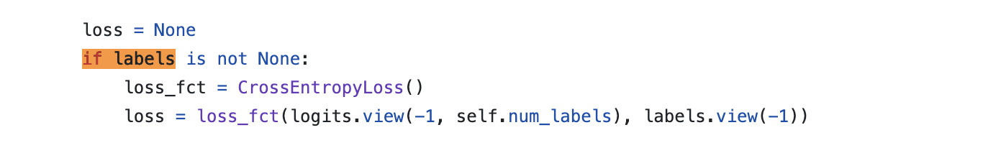
Figure 1: symmetric loss function from https://github.com/huggingface/transformers/blob/main/src/transformers/models/distilbert/modeling_distilbert.py

- Notice the 3rd line in the Figure 1. When the model is initialized using “DistilBertForSequenceClassification” (line 81 in src/train_custom_model.py), Hugging Face loaded a specific Python file from its library (modeling_distilbert.py), and it defaults to a standard PyTorch function called CrossEntropyLoss() (ie: 3rd line in Figure 1). Notice that the parentheses are empty in CrossEntropyLoss(). It’s not passing any instructions or weights into the function.
- Since Hugging Face relies on PyTorch to do the math, we will take a look at the PyTorch documentation for torch.nn.CrossEntropyLoss.
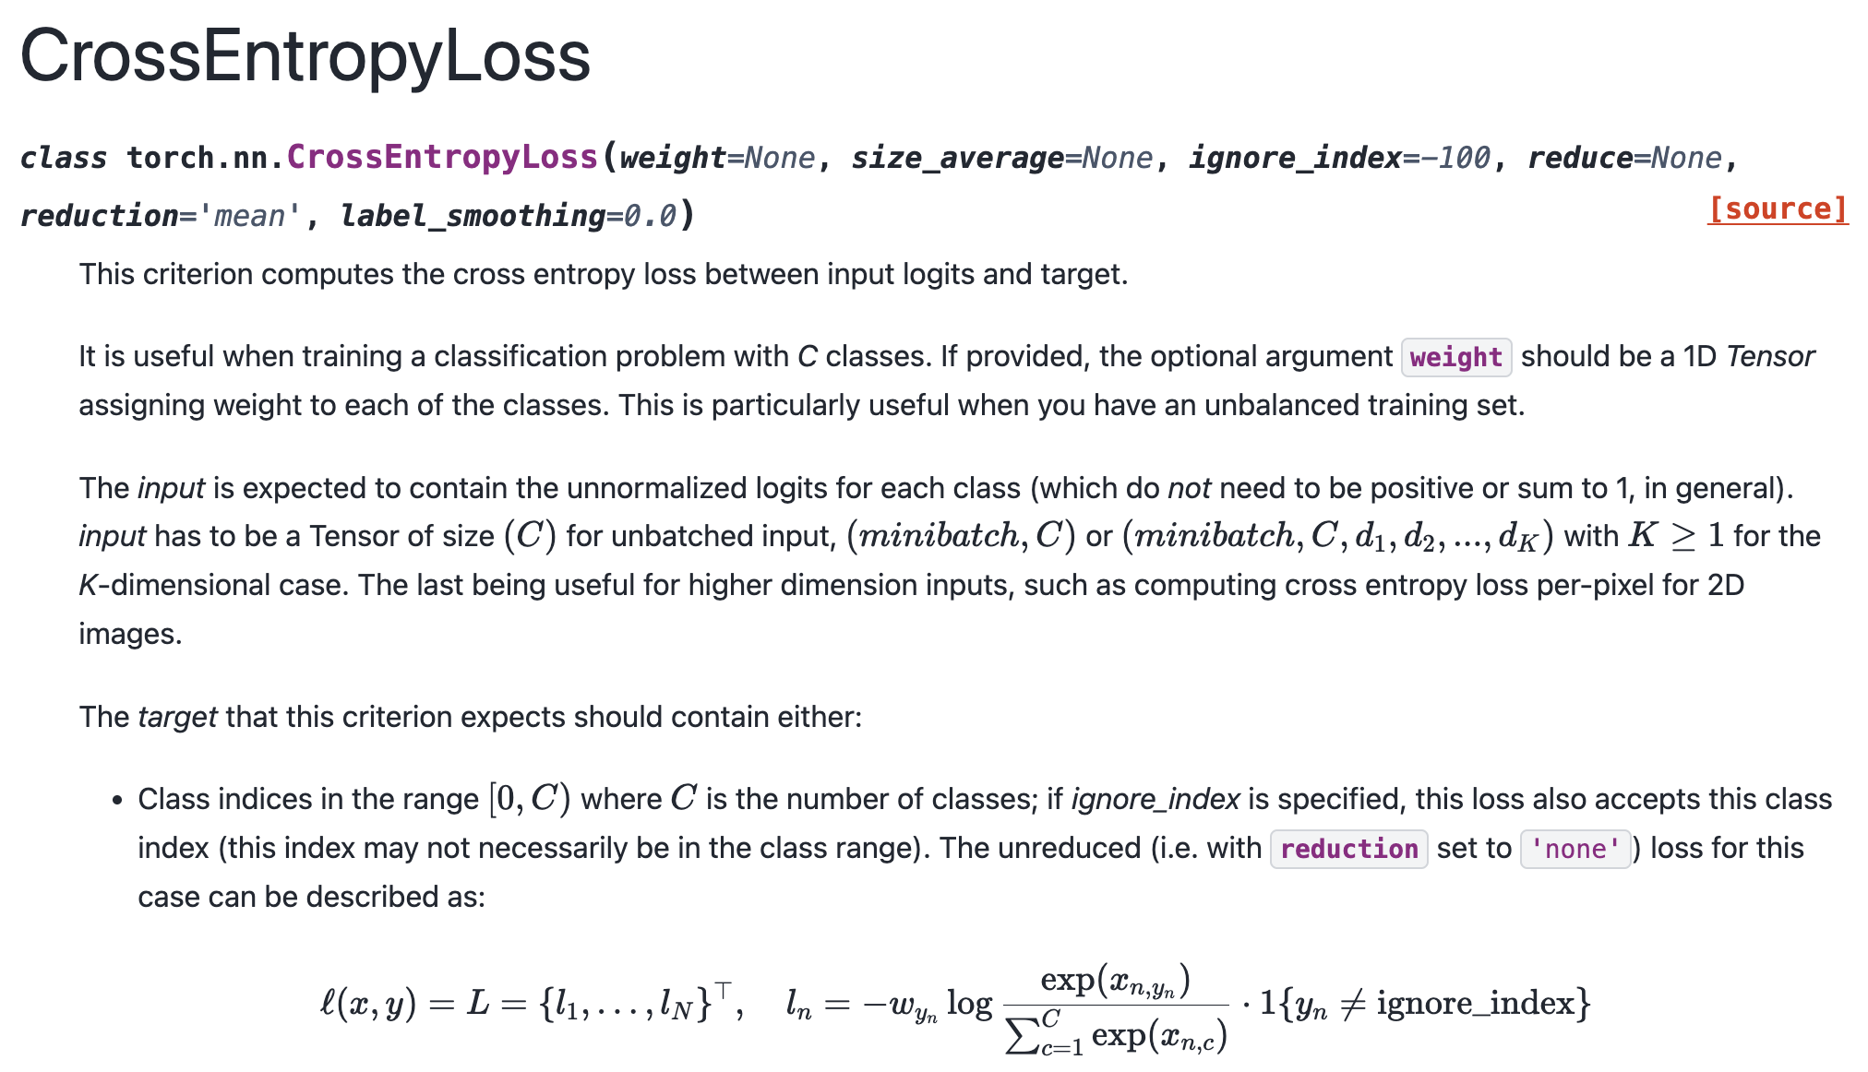
Figure 2: CrossEntropyLoss() function from PyTorch Documentation site: https://docs.pytorch.org/docs/2.12/generated/torch.nn.CrossEntropyLoss.html

- Notice that the “weight” parameter is optional, and it assigns weight to each of the classes.
- Also for the loss function L$n$ in the bottom, the fraction inside the log() is exactly the Softmax probability of the true class:

$$p_{y}=\frac{exp\left(x_{y}\right)}{sum_{c=1 }^{C}exp\left(x_{c}\right)}$$
(Where p_y is the probability assigned to the correct (true) class, not necessarily the class that the model predicts.)

- Thus, we can substitute p_y into the original L$n$ equation:
$$\ln{= -w_{y}*log⁡(p_{y})}$$
- When “weight = none”, w_y = 1 for every class, which makes our equation become:
$$\ln{= -log⁡(p_{y})}$$
- Now for example, if the true label is 0 (Benign), and the model predicts [0.1, 0.9] (meaning 10% Benign, 90% Malicious, obtained after Softmax function converted raw logits into probability), cross entropy loss is:

L = -1 * log (0.1) = 2.3

- If the true label is 1 (Malicious), and the model predicts [0.9, 0.1] (meaning 90% Benign, 10% Malicious), cross entropy loss is:

L = -1 * log (0.1) = 2.3
same loss for both class when a miss-classification happens.

- Solution:
- However, since our objective for the project is to minimize FPR rate, ideally < 5%, we must add more penalty when the model blocks a safe prompt (False Positive). Thus, we overrode the default loss function and introduced a custom multiplier (or weight) to create an Asymmetric Penalty.

- We defined:
  - W_benign = 3.0 (Class 0: Safe prompts)
  - W_malicious = 1.0 (Class 1: Injection prompts)

- So now, if the model:
  - Misses an attack (False Negative): The model predicts Safe (0), but the answer is Injection (1), the base penalty/loss is multiplied by w_malicious = 1.0
  - Blocks a safe prompt (False Positive): the model predicts Injection (1), but the answer is Safe (0), the base penalty is multiplied by w_benign = 3.0, essentially triple the penalty/loss
- In line 89-91 in src/train_custom_model.py, we defined our w_tensor = [3.0, 1.0], then injected it in line 117 in our custom “WeightedTrainer” defined at the top of the script. Once the WeightTrainer is initialized, its __init__ function catches the w_tensor that we passed in and saves it in the variable self.class_weights.
- During training, the compute_loss() function will run and grab the self.class_weights, moves them to Mac’s GPU, and plugs them into PyTorch’s CrossEntropyLoss() function as “weight = class_weights”.
- Now that False Positives will generate much larger losses, during error back propagation, since larger losses produce larger parameter updates, this encourages the optimizer to focus more strongly on correcting false-positive errors. Over successive training iterations, this shifts the model toward a more conservative decision boundary, reducing the likelihood of incorrectly classifying benign prompts as malicious and thereby lowering the False Positive Rate (FPR).

Strategy 3: Isolating validation loop
- Problem:
- The Overfitting Trap: If a model trains for too long, it begins to memorize the training data rather than learning general patterns. As we observed during our training logs, extended training caused the model to aggressively cast a wider net to catch every single attack. While this improved Recall, it increased the False Positive Rate (FPR), pushing it from a safe 3.76% up to 5.26%.
- Evaluation Data Leakage: To know when to stop training, engineers need to test the model's progress. If we test the model using our final 20% Test Set, we ruin the scientific integrity of the project. Every time we tweak our w coefficients or learning rate based on those Test Set scores, the model indirectly "learns" the test data. By the time of the final evaluation, the test is no longer blind, rendering the metrics invalid.

- Solution: We will finally use the 16% Validation set created in Milestone 2a. The training loop will learn from the 64% Train set, and at the end of every “epoch” (full pass of the data), it will auto-test itself on the Validation set. We will use this to tweak our learning rates and w coefficients without touching the frozen Test set:
  - The 16% Buffer Zone: Instead of a standard 2-way split, we utilized the 3-way dataset split generated in Milestone 2a. We allocated 64% of the data strictly for training and set aside a 16% Validation Set. This validation partition acts as a safe "sandbox" where the model can be graded without ever touching or seeing the frozen 20% Test Set.
  - Automated Epoch Grading: We configured the Trainer with eval_strategy="epoch". This forces the training engine to pause at the end of every complete pass of the training data. While paused, the model runs a temporary evaluation against the 16% Validation Set and logs its current Accuracy, F1, and FPR.
  - Algorithmic Model Selection: We passed three critical parameters into the training arguments to automate our quality control:
    - load_best_model_at_end=True
    - metric_for_best_model="fpr"
    - greater_is_better=False
  - By doing this, the script actively monitors the FPR at the end of every epoch. When Epoch 3 finished and the model overfitted (causing the FPR to spike above the 5% enterprise limit), the training algorithm automatically discarded Epoch 3's weights. It reached back into its checkpoints, retrieved the weights from the epoch with the lowest FPR, and saved that optimal version as the final architecture.

Result after 3 epochs:

[
{
"eval_loss": 0.2212056964635849,
"eval_accuracy": 0.8516421291053228,
"eval_precision": 0.9230769230769231,
"eval_recall": 0.6837606837606838,
"eval_f1": 0.7855973813420621,
"eval_fpr": 0.03759398496240601,
"eval_runtime": 19.9092,
"eval_samples_per_second": 44.351,
"eval_steps_per_second": 2.813,
"epoch": 1.0,
"step": 221
},
{
"eval_loss": 0.1929044872522354,
"eval_accuracy": 0.8844847112117781,
"eval_precision": 0.9399293286219081,
"eval_recall": 0.7578347578347578,
"eval_f1": 0.8391167192429022,
"eval_fpr": 0.03195488721804511,
"eval_runtime": 19.3916,
"eval_samples_per_second": 45.535,
"eval_steps_per_second": 2.888,
"epoch": 2.0,
"step": 442
},
{
"loss": 0.24142088317871094,
"grad_norm": 6.099514484405518,
"learning_rate": 4.9472096530920064e-06,
"epoch": 2.262443438914027,
"step": 500
},
{
"eval_loss": 0.21763460338115692,
"eval_accuracy": 0.9060022650056625,
"eval_precision": 0.906060606060606,
"eval_recall": 0.8518518518518519,
"eval_f1": 0.8781204111600588,
"eval_fpr": 0.05827067669172932,
"eval_runtime": 23.3589,
"eval_samples_per_second": 37.802,
"eval_steps_per_second": 2.397,
"epoch": 3.0,
"step": 663
},
{
"train_runtime": 1247.9161,
"train_samples_per_second": 8.486,
"train_steps_per_second": 0.531,
"total_flos": 1402829751767040.0,
"train_loss": 0.20669793003824502,
"epoch": 3.0,
"step": 663
}
]

Result analysis:

The custom DistilBERT architecture successfully mitigated the architectural blind spots of the ProtectAI baseline. By implementing left-side tokenizer truncation and an asymmetric loss function (w_benign = 3.0, w_malicious = 1.0), the custom model increased the overall F1-score by nearly 18% while successfully dragging the False Positive Rate (FPR) below the strict 5% enterprise requirement.

Comparative Performance Matrix:

Metric | ProtectAI Baseline | Custom DistilBERT (Optimal Epoch 2) | Net Improvement
False Positive Rate (FPR) | 21.32% | 3.19% | - 18.13% (Passes < 5% Rule)
F1-Score | 66.05% | 83.91% | + 17.86%
Recall | 65.30% | 75.78% | + 10.48%
Precision | 66.82% | 93.99% | + 27.17%
Accuracy | 73.37% | 88.44% | + 15.07%

Final customized DistilBERT model:

Since our script chooses the optimal Epoch based on lowest FPR score, epoch 2 with FPR = 3.19% was chosen as our final customized model and will be saved inside the models/custom_distilbert/ folder:

- Its architecture blueprint containing the core parameters of DistilBERT (ie: number of attention heads & layers, modifications that was made such as setting it up for binary classification) will be saved in the models/custom_distilbert/config.json file.

- model.safetensors: This is the actual "brain" of the AI. It is a massive file containing all the mathematical weights (the millions of numerical connections) that the model learned during training. It is saved in the modern .safetensors format, which is much faster and more secure than older PyTorch formats.

- tokenizer_config.json, vocab.txt, tokenizer.json, special_tokens_map.json: These four files make up the custom Left-Truncating Tokenizer. They dictate exactly how the model chops up incoming English (and non-English) sentences into mathematical tokens before feeding them to the model.safetensors brain.

Also, under the models/custom_distilbert_checkpoints/ folder, there are 3 subfolders:

- checkpoint-221
- checkpoint-442
- checkpoint-663

These are the direct result of the math we did earlier. Because we calculated that 1 Epoch = 221 steps (each step = 16 prompts, 16*221 ~ 3530 total prompts = Train set), the Hugging Face Trainer created a full physical backup of the model's brain at the exact moment each epoch finished:

- checkpoint-221 contains the model exactly as it existed at the end of Epoch 1.
- checkpoint-442 contains the model at the end of Epoch 2 (221 × 2).
- checkpoint-663 contains the overfitted model at the end of Epoch 3 (221 × 3).

Also note that Epoch 2 and 3 has 2 sets of results each because our script generates a set of result at the end of each epoch, while Hugging Face Trainer is also programmed to print an update on the internal training math every exactly 500 steps (epoch 2.26 Trainer hit step 500, each epoch = 221 steps 500 / 221 steps = epoch 2.26), as well as the Global Training Summary (also programmed by Hugging Face) to auto generate a final receipt for the entire process, showing how long the whole 3 epoch job took and the total mathematical operations it performed.
Evaluate the customized DistilBERT model on Test set:

Result:

{
"model": "custom_distilbert_v1",
"dataset_size": 1104,
"accuracy": 0.8795,
"precision": 0.9248,
"recall": 0.758,
"f1_score": 0.8331,
"false_positive_rate": 0.0405,
"false_positives": 27,
"false_negatives": 106,
"true_positives": 332,
"true_negatives": 639
}

Result analysis:

The custom custom_distilbert_v1 architecture successfully passed the final blind evaluation on the frozen 20% Test Set (1,104 prompts). By implementing left-side token truncation and asymmetric loss weights, the model achieved an 83.31% F1-Score while successfully dragging the False Positive Rate (FPR) down to 4.05%. This officially satisfies the strict enterprise constraint requiring an FPR of less than 5%, fulfilling the target originally proposed in the contract.

Metric | Final Score | Business Interpretation
False Positive Rate (FPR) | 4.05% | PASS: Safely below the 5% maximum threshold limit.
F1-Score | 83.31% | Strong balance between precision and recall against complex text.
Precision | 92.48% | Extremely high confidence; if the model flags an attack, it is almost certainly malicious.
Recall | 75.80% | Caught the majority of attacks, even when buried inside complex jailbreak formats.
Accuracy | 87.95% | Overall structural correctness across all categories.

Raw classification count:

- True Negatives (TN): 639 safe prompts correctly allowed.
- True Positives (TP): 332 attacks successfully blocked.
- False Positives (FP): 27 safe prompts incorrectly blocked. (Reduced to an acceptable operational minimum).
- False Negatives (FN): 106 attacks missed.

Baseline Comparison & Conclusion:

When compared to the industry-standard ProtectAI baseline evaluated in Milestone 2b, the custom DistilBERT architecture demonstrates a profound security upgrade:
- FPR Reduction: Dropped from 21.32% down to a highly stable 4.05%, rescuing the user experience from continuous false alarms.
- F1-Score Surge: Improved from 66.05% to 83.31%, proving the model successfully learned to identify the semantic intent of complex, multi-turn jailbreaks rather than just surface-level keywords.

